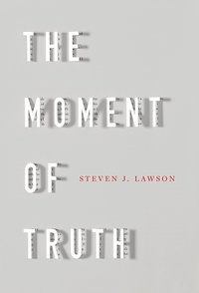
February 3 2019
The Moment of Truth by Steven J. Lawson (230 LAW). “What is Truth?” Pilate turned to Jesus and asked a profound question. It is a question that continues to be debated in our day. But it is one that God had definitively answered in His written Word and ultimately revealed in the incarnate Word, Jesus Christ. Though the world may redefine truth or deny it’s existence altogether, it has been the duty and privilege of each successive generation of Christians to proclaim and defend the truth of the gospel to a world that desperately needs to hear it. In this collection of sermons, Dr. Steven J. Lawson speaks into our cultural moment, helping Christians and skeptics alike answer Pilate’s age-old question. “In our moment in human history, we must advance and hold the battle line secure for the next generation. We must be fully engaged as this war on the Word rages, seeking to uphold the standard of sound words and earnestly contend for the faith.”

February 10
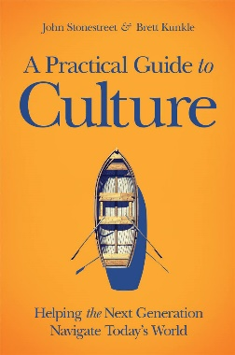
A Practical Guide to Culture – Helping the Next Generation Navigate Today’s World by John Stonestreet & Brett Kunkle (261 STO). God’s story is bigger than this cultural moment. Something has changed. We all sense it. Cultural pressure is increasing, especially on our kids. But even in a world of addictions, every-present screens, and gender-identity questions, youth can have clarity and confidence. We must help them attain it. In this honest and practical guide for parents and Christian leaders, John Stonestreet and Brett Kunkle explore questions such as: What unseen undercurrents are shaping twenty-first-century youth culture? Why do so many kids stuggle with identity? How do we talk to kids about LGBT. How can we steer kids away form substance abuse and other addictions? How can we ground students in the biblical story and empower them to change the world? This inspiring book will enable you to help your kids influence the culture, rather than let the culture change them.

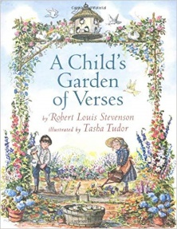
February 17
A Child’s Garden of Verses – A Collection of Scriptures, Prayers, & Poems by Thomas Kinkade featuring works of Robert Louis Stevenson (YOUTH DEV KIN). Introduce your child to this delightful literary heritage, filled with the classic poems of Robert Louis Stevenson, as well as favourite selections from Mother Goose, Robert Browning, Lewis Carroll, Christina Rossetti, and others. These favourite poems are interwoven with Scriptures and heartfelt prayers for children, and are brought to life with the beautiful paintings of acclaimed artist Thomas Kinkade.

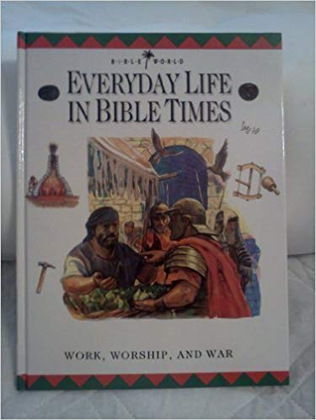
February 24
Everyday Life in Bible Times – Work, Worship, and War by Margaret Embry (YOUTH 220 EMB). A bustling marketplace . . . local craftworkers selling their wares . . . merchants offering treasures brought from distant lands . . . powerful men riding by in their chariots . . . beggars with outstretches hands . . . . This book recreates the atmosphere of Bible times. It explores the places where people lived and worked, the smelly workshops, the teeming marketplaces, the splendid temples, the opulent palaces, and the mighty fortresses. This series uncoves the exciting real-life story of the Bible.

