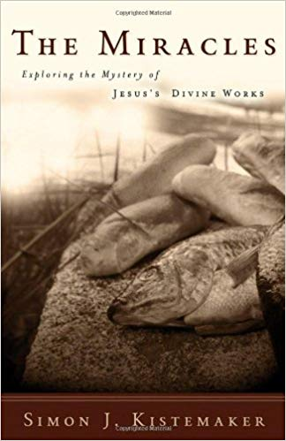
April 7 2019
The Miracles – Exploring the Mystery of Jesus’s Divine Work by Simon J. Kistemaker (232.955 KIS). Rediscover the mystery. We’ve heard the stories about Jesus calming the storm, feeding the five thouusand, and healing the blind. But they can seem so far removed from our experience of following Jesus today. What would it have been like to witness these events firsthand? Simon Kistemaker helps you take a closer look at the miracles of Jesus to better understand the purpose behind each one. By carefully laying out cultural background, symbolism, and Old Testament connections, Kistemaker shows you how these miracles relate to the way you follow Jesus. The result is a detailed exploration that will deepen your understanding of Jesus’s miraculous works.
April 14
A Heart Set Free – A Journey to Hope Through The Psalms of Lament by Christina Fox (223.2 FOX). For many of us, we might busy ourselves with projects or work long hours to keep our mind off our pain. We might look at our circumstances and seek to change our situation, in the hope that we will finally feel at peace once our life has changed. The question is -- How often do you look to God in His Word for help and hope? How often do you turn to Him when you feel anxious, distraught, or abandoned? How often do you bring your burdens to your Saviour? Take a journey of hope through the Psalms of Lament with Christina Fox.

April 21
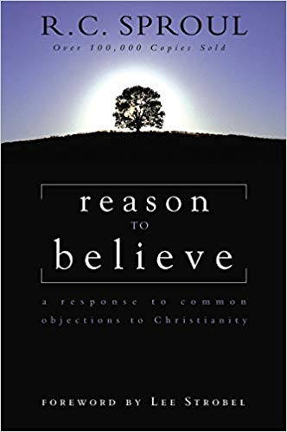
Reason to Believe – A Response to Common Objections to Christianity by R. C. Sproul (239 SPR). Do Christians have good answers for the really tough questions? Dr. R. C. Sproul believes they do. In this unique book he deals with the most common objections to the truths of the Christian faith: Has science disproved the existence of God? Will pagans who never hear of Christ go to hell? Is it narrow-minded and bigoted to believe there is only one way to God – through Christ? Why do people need religion when life is going smoothly? Do Christians believe in God because they need a crutch to face life’s pressures? Is heaven real or just “pie in the sky”? Do Christians have a good answer to evil and suffering? How does the church explain all its hypocrites?
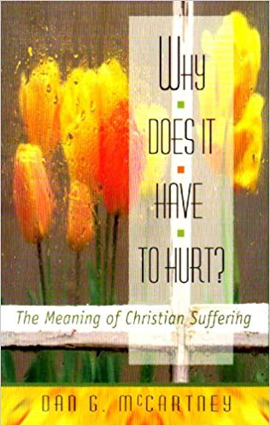
April 28
Why Does It Have to Hurt? – The Meaning of Christian Suffering by Dan McCartney (248.86 MCC). Honest questions about suffering deserve honest answers. We all experience suffering, some of us more than others. In fact, if you’re a Christian, you’ve been called to suffer with Christ. But why do Christians suffer? Isn’t God all-powerful, able to prevent suffering? Isn’t He loving and good, particularly toward His children? What prupsoe does suffering serve in my life, or the lives of my loved ones? Why does it have to hurt?

