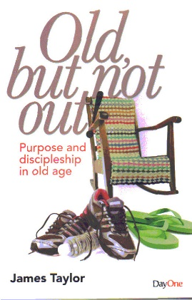
JUNE 2018
June 3
Old, But Not Out! – Purpose and Discipleship in Old Age – by James Taylor (248.85 TAY) – In the UK, the elderly population is increasing and the suggestion we get from the media is that this is unremittingly negative. This book looks at a number of Scripture passages which remind older Chrisians that they still have enormous value and purpose, and will encourage their pastors to see that they remain a great resource. Old age brings with it the need for many adjustments but also many responsibilities and joys and so the purpose of this book is to point to where Scripture provides both rassurance and encouragement for those in this ‘third age’ of life.
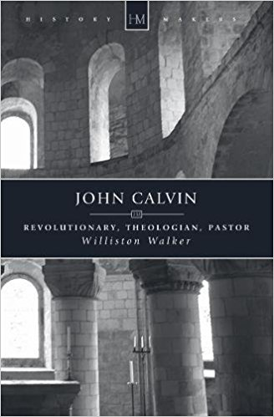
June 10
John Calvin – Revolutionary, Theologian, Pastor by Williston Walker (BIO WAL) – Greater than any other Reformation era figure, John Calvin stimulated the debate, thoughts and ideas that have come to dominate Western culture and society. Dedicated to the reform of the church, and insistent on a literalistic reading of scripture, his influence radically changed the face of Protestantism and Society. Society’s abhorrence of corruption in government, and the correspondent lack of it in Western Democracies, is largely down to his work. He was the first major political thinker to model social organisation on Biblical principles, one of his most important innovations being the incorporation of the church into city government. As a result, Geneva became the most important Protestant centre of Europe in the 16th Centurey. Calvin’s transformation of th epolitical, social, philosophical and cultural landscape of Europe permeates the doctrine of Presbyterian, and other Reformed churches world wide, to this day.
June 17
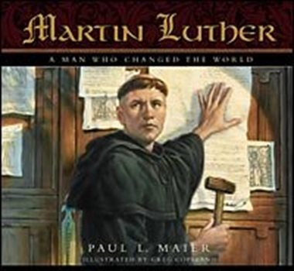
Martin Luther – The Man Who Started the Reformation by Thomas Lindsay (BIO LIN) – Martin Luther’s father was a miner with ambitions – he wanted to better himself and provide his childeren with a good education. Martin upset his father’s plans by becoming a monk rather than a lawyer, but by the age of 29 he was a Professor of Theology. In addition to his college duties he preached almost every day and visited people on pastoral duties – he kept two secretaries very busy. Luther’s father, meanwhile, became a town councillor, the part owner of six mines and two foundries and owned a large house in the main street. What happened to make this son of the upwardly mobile establishment into a revolutionary who nailed 95 Theses onto the church door at Wittenberg, affecting not only the whole of the Christian Church but also breaking the power of a European superstate? This is the story of a passionate, flawed and courageous man who loved his family and the people around him; a man who went further in challenging the status quo than any other in history, the man who started the Reformation.
June 24
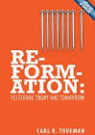
Reformation: Yesterday, Today and Tomorrow by Carl R. Trueman (270.6 TRU) – In his lively and engaging style Carl Trueman examines the origins of contemporary Reformation theology in the Reformation world of the sixteenth and seventeenth centuries. Afer tracing how this heritage shapped and transformed the intervening period, he then describes the major challenges now being faced by today’s evangelical church. Not content to leave it like this he goes on to suggest ways of responding to these challenges, ways that remain faithful to Scripture and theology of the Reformers drawn from the pages of God’s word. He then points expectantly towards a future where the church embraces and radiates these wonderful doctrines of grace.

