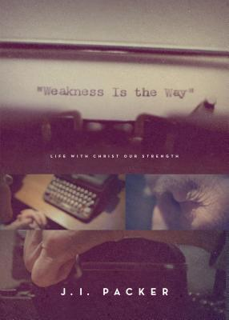
June 2 2019
“Weakness Is the Way” – Life with Christ Our Strength by J. I. Packer (248.4 PAC). For Christians weakness should be a way of life. Yet most of us try desperately to be sufficient on our own, and we resent our limitations and our needs. Renowned theologian and Bible teacher J.I. Packer reflects on his experience of weakness – having been hit by a truck at a young age and now facing the realities of aging – in order to teach us the importance of embracing our own frailty, and also to help us look to Christ for strength, affirmation, and contentment. Find here a path from discouragement to freedom in light of our all-sufficient God.
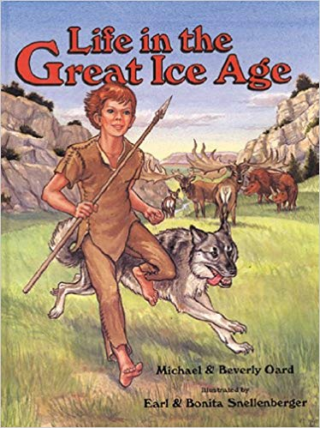
June 9
Life in the Great Ice Age by Michael & Beverly Oard (Youth Non-Fic OAR). After Noah’s Flood the earth and its climate were undergoing drastic changes. The stage had been set for the Great Ice Age. Noah’s descendants had to learn how to survive in a strange often hostile land. In part one of Life in the Great Ice Age, we’ll spend a summer with Jabeth and his family as they survive a saber-toothed tiger attack, battle a cave bear, and go on a woolly mommoth hunt. Part two explains the scientific reasons for the Ice Age: what caused it, and how long it lasted. It answers the question, “Will there be another Ice Age?” Archaeological and fossil finds are also discussed in detail in this exciting book that explains the Great Iice Age from a Biblical perspective.
June 16
Happiness by J. C. Ryle (204.2 RYL). This book addresses a topic that has fascinated mankind and remains a hot topic today: what is true happiness? How can it be found and held on to, even when life throuws a curved ball? Ryle gives answers you can trust and that all Christians will find helpful.
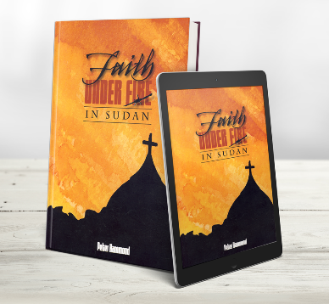
June 23
Faith Under Fire in Sudan by Peter Hammond (272 HAM). Africa’s Forgotten War - The longest war of the 20th century – in the largest country in Africa, Sudan. From 1955 the Muslim Arab North attacked the Christian Black South. The first editions of Faith Under Fire in Sudan lifted the virtual news blackout on this colossal conflict and exposed the scorched earth tactics, systematic terror bombing of civilian targets and the resurgence of the slave trade in Sudan. Now the author has greatly updated and expanded the book to include more recent first-hand accounts of the horrific atrocities and the inspiring stories of Christian faith. This book will introduce you to some of the unforgettable heroes of Sudan and their legacy.
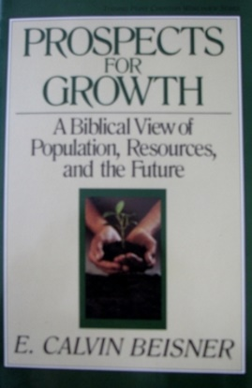
June 30
Prospects for Growth – A Biblical View of Population, Resources, and the Future by E. Calvin Beisner (261.8 BEI). The warnings are loud and clear: the world is dangerously overpopulated; natural resources are becoming scarce; holes in the ozone layer could lead to the death of our planet. Are these accurate predictions we ignore at our own peril, or are they politically motivated scare tactics designed to promote a radical agenda? In this important book, respected author E. Calvin Beisner brings Biblical principles of theology, anthropology, and ethics to bear on these crucial questions. What do the Scriptures say about population, freedom/civil government, natural resources, management of the environment? Is man meant to be servant, master, or steward of the earth?

