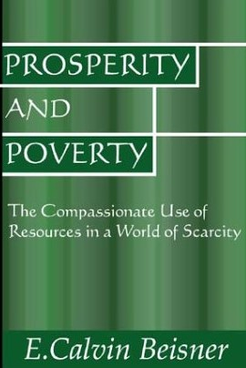
July 7 2019
Prosperity and Poverty – the compassionate use of resources in a world of scarcity by E. Calvin Beisner (261.8 BEI). We live in a world with millions in need, a nation torn by conflicting ideologies that offer failing remedies for economic ills. Yet the gospel calls Christians to feed the hungry and care for the poor. But how? Prosperity and Poverty offers clear teaching on Biblical principles of stewardship and economics, enabling us to make informed choices in these areas. The stakes are high. Our decisions mean the difference between starvation and plenty, between liberty and oppression, for tens of millions of people.

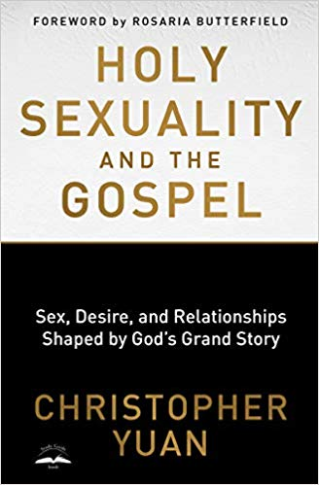
July 14
Holy Sexuality and the Gospel – Sex, Desire, and Relationships Shaped by God’s Grand Story by Christopher Yuan (261.8 YUA). How do we apply the essence of the gospel to a gay loved one? In what ways can we better walk with truth and grace alongside a fellow Christian with same-sex attractions? Holy Sexuality and the Gospel offers theological and practical insights that lead us to find our identity in Christ – not in our sexuality. Whether you want to share Christ with a loved one who identifies as gay or you’re wrestling with questions of identity yourself, this book will help you better understand sexuality in light of God’s grand story and realize that holy sexuality is actually good news for all.

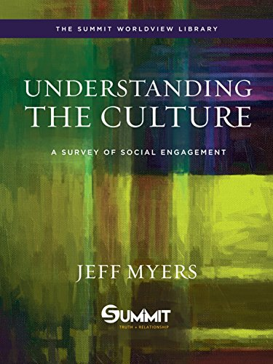
July 21
Understanding the Culture – A Survey of Social Engagement by Jeff Myers (261.8 MYE). Living out a Christian worldview in today’s culture. What difference would it make if we consistently applied a biblical framework to today’s most challenging issues? Abortion, euthanasia, sexuality, marriage, creation care, religious liberty, and more. This book is an invitation to engage the world based on God’s intended design. Through story, personal reflection, and biblical insight, Jeff Myers, one of the leading Christian worldview thinkers today, addresses several questions.

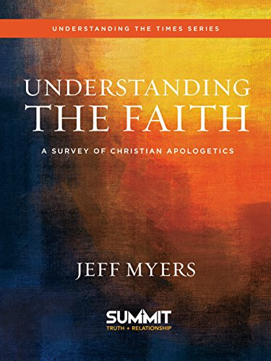
July 28
Understanding the Faith – A Survey of Christian Apologetics by Jeff Myers (239 MYE). Does the Bible have authority in a world committed to relative truth? The understanding of absolute, objective truth has been largely lost. Spend just a few minutes discussing politics or religion and you’ll hear responses such as “There is no truth” or “That may be true for you, but not for me.” Understanding the Faith dares to wade into the middle of the controversy with chapter titles that include “Is God Christian?”, Isn’t Claiming Truth Intolerant?” “Isn’t Christianity Anti-Science?”

