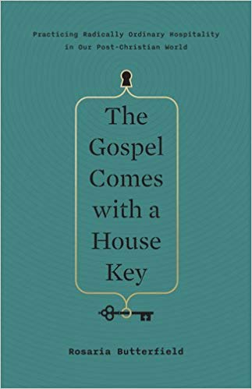
August 4 2019
The Gospel Comes with a House Key – Practicing Radically Ordinary Hospitality in our Post-Christian World by Rosaria Butterfield (241.671 BUT). This book will stir your imagination to generate creative ways to incorporate radically ordinary hospitality into you own life. This book is the aurthor’s heart reaching out to our hearts, calling us to love our neighbours with sacrificial hospitality. Butterfield makes a bold case for putting hospitality back into the essential rhythm of the church’s daily life. This book isn’t for those who want to live the comfortable Christian life. Rosaria proves there is no such thing.
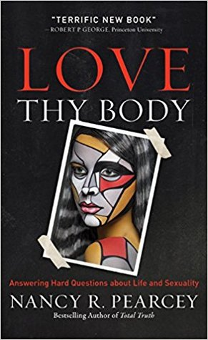
August 11
Love Thy Body – Answering Hard Questions About Life and Sexuality by Nancy R. Pearcey (241.697 PEA). “Liberal secularist ideology rests on a mistake, and Nancy Pearcey in her terrific new book puts her finger right on it. In embracing abortion, euthanasia, homosexual conduct and relationships, transgenderism, and the like, liberal secularism . . . is philosophically as well as theologically untenable.”

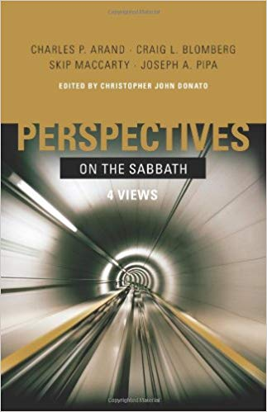
August 18
Perspectives on the Sabbath (4 Views) by Charles P. Arand, Craig L. Blomberg, Skip Maccarty & Joseph A. Pipa (263.1 ARA). “Remember to dedicate the Sabbath day: You are to labour six days and do all your work, but the seventh day is a Sabbath to the Lord your God.” Exodus 20:8-10a. Aiming to determine which is most faithful to Scripture, Perspectives on the Sabbath presents in point-counterpoint form the four most common views of the Sabbath commandment that have arisen throughout history, representing the major positions held amonth Christians today.

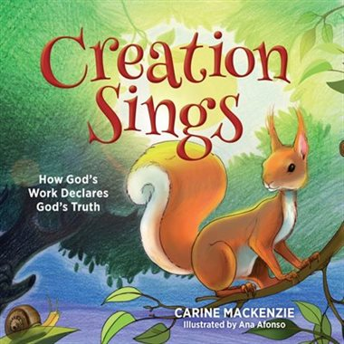
August 25
Creation Sings – How God’s Work Declares God’s Truth by Carine Mackenzie (P MAC). Listen as the heavens declare the glory of God. Watch as the sky above proclaims His handiwork. (Psalm 19:1) And learn from the one true God as His work shows you who He is and what He is like. Powerful, Crreative, Just, Merciful. Creation sings about Him! God’s work declares God’s truth! Each day of Creation links in to Old and New Testament stories that teach us more about God the Father, God the Son and God the Holy Spirit … the Creator.

