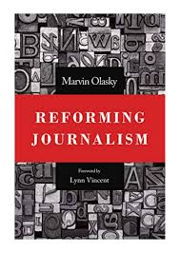
September 6 2020

Reforming Journalism by Marvin Olasky (70.4 OLA). Is powerful, biblically principled journalism a lost art? In this three-part work on foundational concepts, practical techniques, and journalism’s agitated history, Marvin Olasky shows us how to become citizen-reporters and discerning consumers of news.

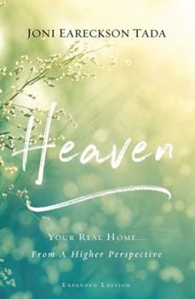
September 13
Heaven Your Real Home . . . From a Higher Perspective by Joni Eareckson Tada (236.24 EAR). For nearly twenty-five years, Heaven has inspired us to live well on earth, even as we long for eternity. Drawing on Scripture, Joni Earekson Tada answers the deepest questions of our hearts about what heaven will be like, who we will see there, and who we will be there. As Joni writed in this updated and expanded edition, she is much closer to heaven than she was when she first wrote about it. It is from this vantage point that she reflects on how we can live for Jesus as we look forward to our real home. A quadriplegic for more than fifty years and a cancer survivor, Joni doesn’t speak lightly when she reminds us that “God knows the precise tools to use in your life to cut, cleanse, and refine the diamond that is your eternal soul . . . . Every good thing that God has ever given will last for all eternity – including the best part of every affliction.” Journey with Joni into the knowledge and the mysteries of heaven, a place that is so inexorably captivating and utterly desirable that it is worth living every day in its light.
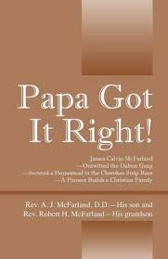
September 20
Papa Got It Right – James Calvin McFarland, outwitted the Dalton Gang, Secured a Homestead in the Cherokee Strip Race and A Pioneer Builds a Christian Family by Rev. A. J. McFarland, his son and Rev. Robert H. McFarland, his grandson (BIO MCF). Robert McFarland was born in Superior, Nebraska, in the midst of Depression. He was the youngest of three sons born to Pastor A. J. McFarland and his wife, Sylvia (Hutcheson). As a two year old, the author moved with his family to the small Western Kanasa community of Quinter. Then during World War 2 the family moved to Topeka, Kansas, where Robert worked at his first job – a bicycle delivery boy for the Topeka State Journal newspaper. From the 7th grade until leaving home for marriage, he lived in Sterling, Kansas. High School was filled with athletics: football, basketball and track. Musical interests were shown in winning a state medal for trumpet and singing in the high school music groups. All of these interests continued in his years at Sterling College and Geneva College in Beaver Falls, Pennsylvania. He graduated from Geneva College, Beaver Falls, Pennsylvania, and the Reformed Presbyterian Seminary in Pittsburgh, Pennsylvania. Following that he completed his Masters’ degree in Education from Indian University in Bollmington, Indiana. A life-long member of the Reformed Presbyterian Church of North America, he has served as the pastor of four Reformed Presbyterian congregations in Pennyslvania and Kansas, as well as several short term pastoral ministries in Northern Ireland. He was moderator of the Reformed Presbyterian Church of North America Synod in 2009. He now lives in Topeka, Kansas, with his wife, Georgia, and his 1930 Model A Ford. Bob and Georgia have three children: Rick, Allison, and Nancey and seven grandchildren.
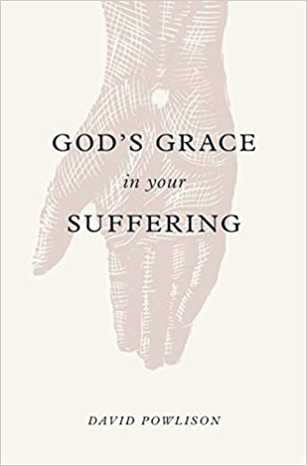
September 27
God’s Grace in Your Suffering by David Powlison (248.8 POW). Where is God? There are never quick fixes or easy answers when it comes to suffering. But even when we can’t immediately see God’s hand – when the struggle is hard and painful – He is working. Weaving together Scripture, personal stories, and the words of the classic hymn “How Firm a Foundation,” David Powlison brings an experienced counselor’s touch to exploring how God enters – and discover how God’s grace goes deeper than we could ever imagine.

