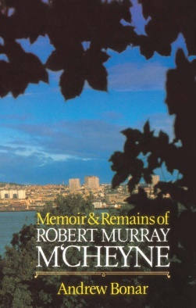
November 3 2019
Memoir & Remains of Robert Murray M’Cheyne by Andrew Bonar (BIO BON). Few books have had such a widespread influence on the lives of God’s people. Testimonies to its usefulness were recived from many lands and Christians of differing theological persuasions have testified to the blessing experienced through reading it. ‘This is one of the best and most profitable volunmes ever published’, said C. H. Spurgeon. ‘The memoir of such a man ought surely to be in the hands of every Christian and certainly every preacher of the Gospel.’ Few books contain such variety and wealth of spiritual matter between their covers.

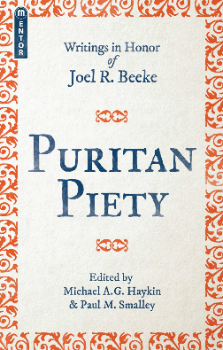
November 10
Puritan Piety – Writings in Honor of Joel R. Beeke by Michale A.G. Haykin & Pual M. Smalley (230 HAY). The puritan movement, its leading figures, and the resulting principles were not only pivotal in Church history, but remain greatly influential today. This work looks at the puritan doctrine of piety. Contributors such as Sinclair Ferguson, Michael Haykin, and Mark Jones explore the theology, history, and appliacation of this doctrine, presenting concise biographies of individual Puritans alongside modern heirs who seek to mimic their example. Puritan Piety is witten in honour of Joel R. Beeke, inspired by his writings and the passionate piety with which he has strived to live and rightly influence those around him.
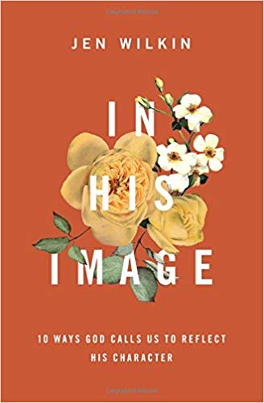
November 17
In His Image – 10 Ways God Calls Us to Reflect His Character by Jen Wilkin (231.4 WIL). Sometimes we ask What is God’s will for my life? When we should really be asking Who should I be? The Bible has an answer: Be like the very image of God. By exploring ten characteristics of who God is – holy, loving, just, good, merciful, gracious, faithful, patient, truthful, and wise – this book helps us understand who God intends for us to be. Through Christ, the perfect reflection of the image of God, we will discover how God’s own attributes impact how we live, leading to freedom and purpose as we follow His will and are conformed to His image.

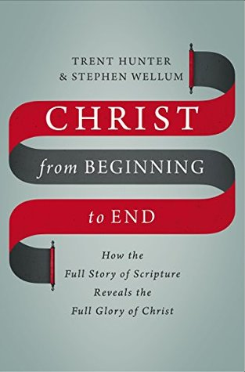
November 24
Christ from Beginning to End – How the Full Story of Scripture Reveals the Full Glory of Christ by Trent Hunter & Stephen Wellum (232 HUN). From beginning to end, the Bible reveals the glory of Jesus. But for many Bible readers, it isn’t that simple. We’re often unsure how the Bible’s many stories, characters, and events relate to each other and connect to Jesus. Some are tempted to force the pieces of the Bible together, making superficial jumps. Others give up trying to understand the Bible at all. Christ from Beginning to End is written to help Christians understand better how every part of Scripture fits to reveal the glory of Christ Jesus.

