July 2017
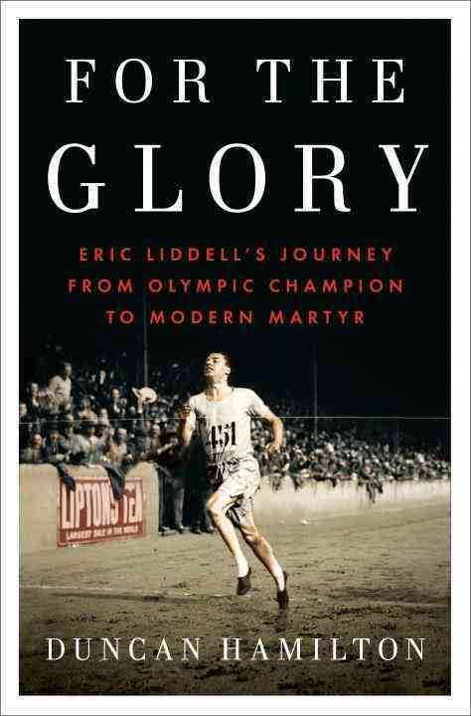
JULY 2
For the Glory by Duncan Hamilton (BIO HAM). The untold and inspiring story of Eric Liddell, Hero of Chariots of Fire. “In this vivid portrait of Eric Liddell, Hamilton show us not only the power of a hero, but also the power of faith. He brings to life a man who was exemplary in his perseverance and unbending in his beliefs when facing adversity. A beautifully written, evocative story of unflinching morality and true humanity.

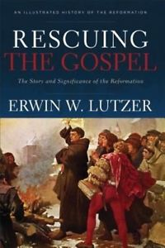
JULY 9
Rescuing The Gospel by Erwin W. Lutzer (HIS 231.76 LUT) “The gospel that Jesus and the apostles proclaimed in the first century is the gospel that Martin Luther and the Reformers proclaimed in the sixteenth century, and it is the same gospel we must proclaim today. With pastoral wisdom passion, Dr. Lutzer explores the remarkable story of the Reformation, and he powerfully demonstrates why the story of the Reformation is, in fact our story. Dr. Lutzer sounds a much needed clarion call to a generation that is quickly turning away from the one and only gospel.”
JULY 16
The Magician’s Nephew by C.S. Lewis (Youth FIC LEW). This is a story about something that happened long ago when your grandfather was a child. It is a very important story because it shows how all the comings and goings between our own world and the land of Narnia first began.

JULY 23
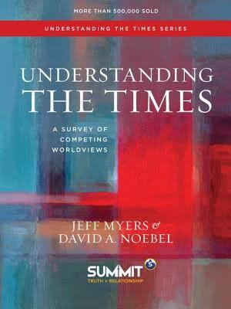
Understanding the Times – A Survey of Competing World Views by Jeff Myers & David A. Noebel (EDU 200 MYE). Your view of God determines your view of the world. Understanding the Times is a systematic way to understand the ideas that rule our world. While the material is expansive, the engaging, easy-to-understand writing style invites you to discover the truths of God and our world.

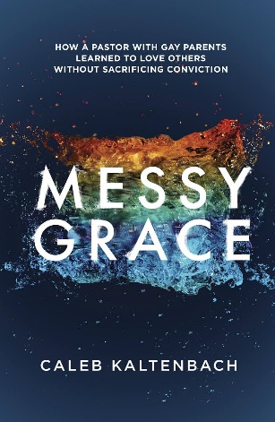
JULY 30
Messy Grace by Caleb Kaltenbach (248.4 KAL). How a pastor with gay parents learned to love others without sacrificing conviction. Caleb Kaltenbach was raised by LGBT parents, marched in gay pride parades as a youngster, and experienced the hatred and bitterness of some Christians toward his family. But then Caleb surprised everyone by becoming a Christian … and a pastor. Messy Grace shows us that Jesus’ command to “love our neighbor as yourself” doesn’t have an exception clause for a gay “neighbour” or any other “neighbour” we might find it hard to relate to. Jesus loved everyone without compromising truth. So can we. Even when it’s messy.

